Table of Contents

**Summary ………………………………………………………………………………………………………………………………2**

**Description** ……………………………………………………………………………………………………………………………….**2**

**Operating instructions** ………………………………………………………………………………………………………….….**3**

Add Events to Calendar …………………………………………………………………………………………………… .3

Add a Video to a Page …………………………..……………………………………………………………………….….6

Adjusting Waiting List ………………….……….……………………………………………………………………….….6

Edit Day Care Status ………………………………………………………………………………………………………….6

Edit Hours of Operation……………………………………………………………………………………………………..6

Editing page content………………………………………………………………………………………………………… 6

**Troubleshooting Techniques** ……………………………………………………………………………………………………**4**

**Summary**

**Description**

**Instructions**

1. **Add Events to Calendar**

Log into the website at <http://outreach.cs.dal.ca/daycare/wp-login.php>

**­­Events Calendar:**

The Event Calendar feature displays events in a calendar format as shown if figure 1.1. Which allows for easy sharing of events. This feature can also be displayed on the (sidebar) right hand side of the page, in text format that can direct the visitor to the calendar format.

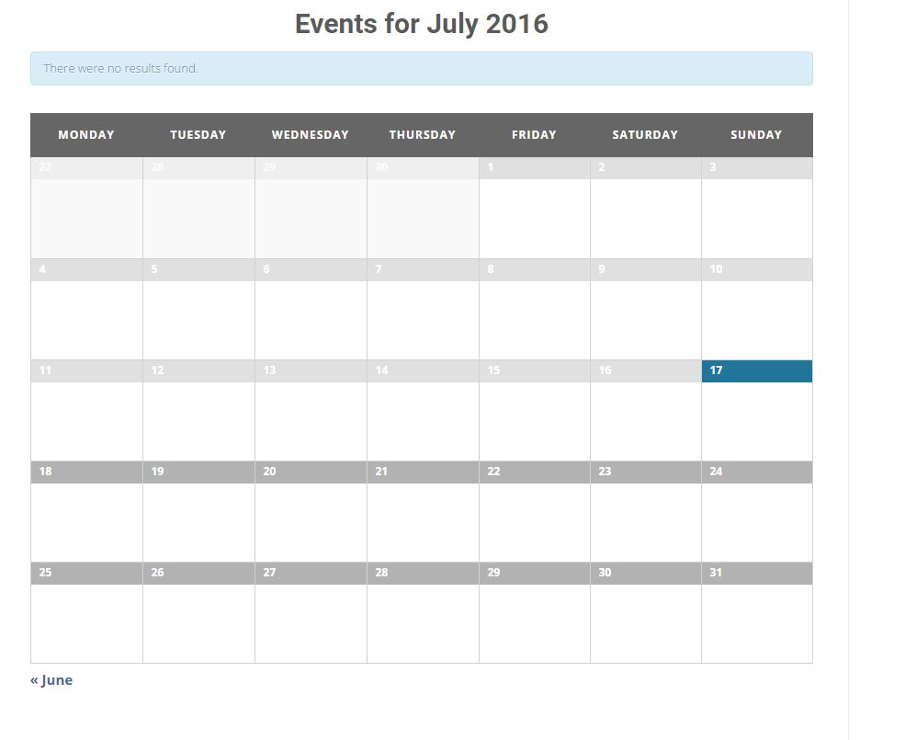

*figure 1.1:* A view of event list in calendar format.

**Administration:**

Follow the steps below to make changes to the Events Calendar feature:

**Adding an event:**

1- On the main administration panel on WordPress as shown in figure 1.2, click on ‘Events” found in the left side Menu bar.

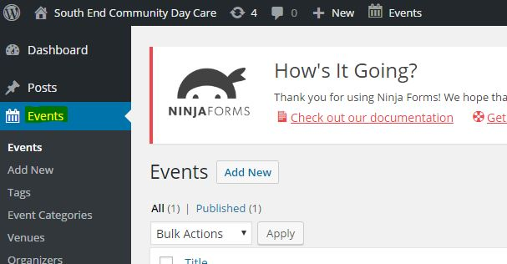

*figure 1.2:* WordPress dashboard having option of managing events.

2- On the Events administration page. select the “Add New” Button located near the “Events” title as shown in figure 1.3.

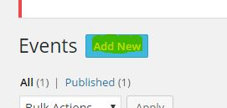

*figure 1.3:* Button highlighted used to add new events.

3- In the Panel shown in figure 1.4, input all the text field area’s that you would like to include for the event including and not limited to title, and event detail. The title area has the following text “Enter title here”. The event detail section is the large text field area directly below the title section.

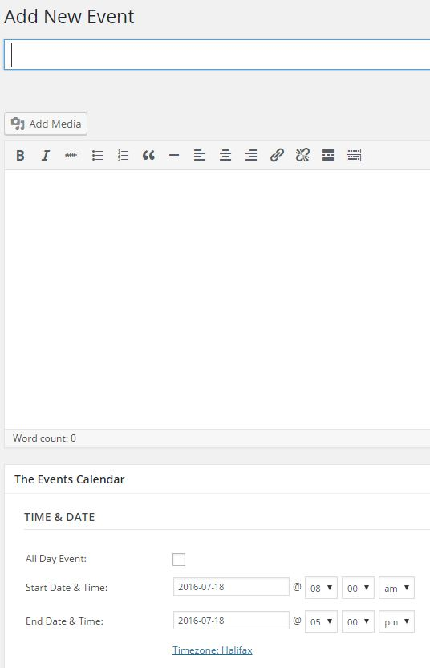

*figure 1.4:* basic description and text fields required to add new event.

4- For adding media files, such as a picture, video, music (mp3). Select the “Add Media” Button found below the title text field as shown in figure 1.5. Once there click the button “Select Files” in the center of the page as shown in figure 1.6, and select a local media file. Once complete select “Insert into Post” button at the right bottom of the page. Doing this will place the media file in the event description.

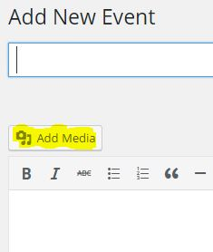

*figure 1.5:* Option for adding a media file.

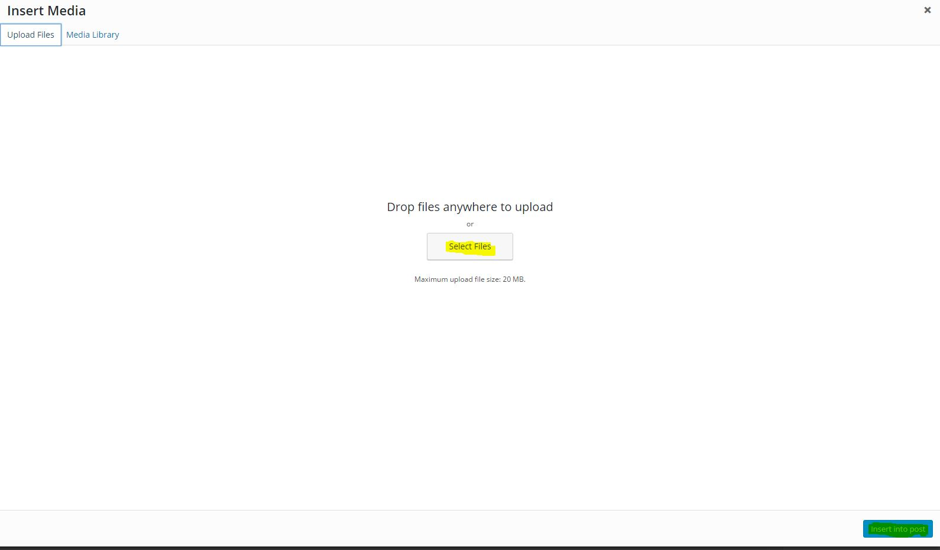 *figure 1.6:* Selecting a media file from Computer.

5- To add more details about the event such as time, date, location, and event organizer. Scroll down the page and various sections are bolded with the specific headings as shown in figure 1.7.

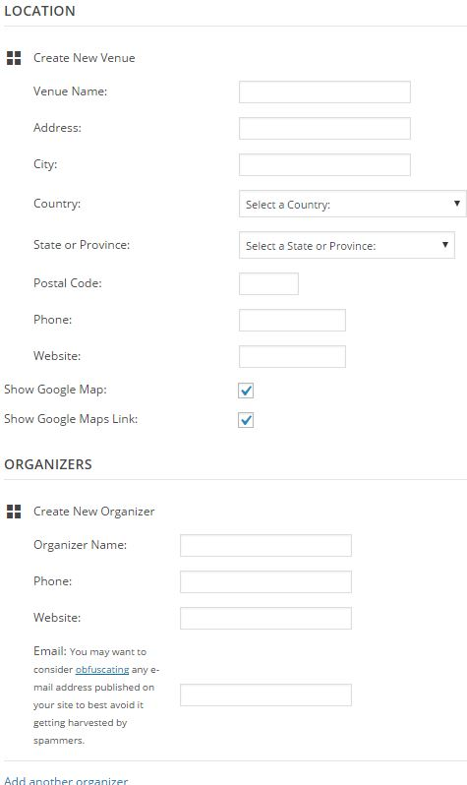

*figure 1.7:* Each field relate to description of an event.

6- Once you are complete with personalizing the event. Select the “Publish” button. At the right top side of the page as shown in figure 1.8. Once complete a message on top of the page should say the following “Event published”.

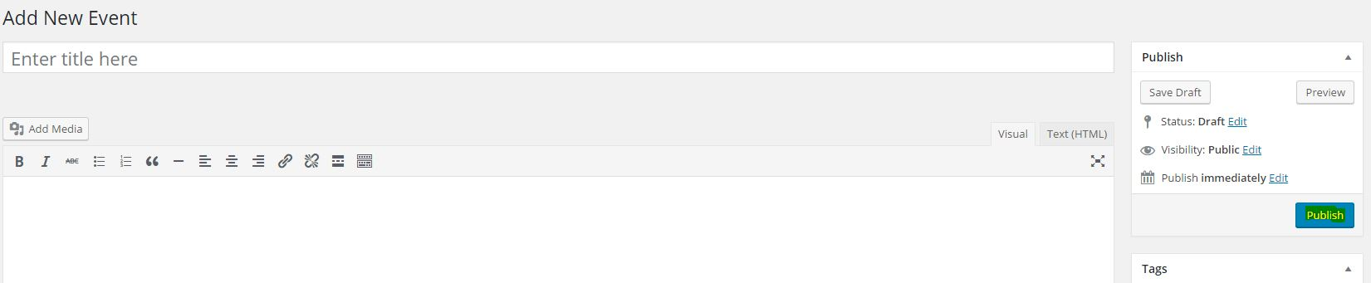

*Figure 1.8:* Publishing an event on website.

**Manage events:**

1- To manage events already made. Go to the “Events” main menu. Which will direct you to a table format of all the events currently in place as shown in figure 1.9.

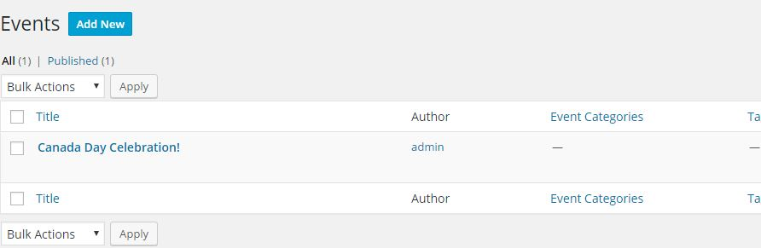

*Figure 1.9:* List of currently published events.

2- To delete one of the events in the table, hover the mouse on the event name, or if on a smartphone select the event name. And various text will appear. Select “Trash” to delete the event as shown in figure 1.10.

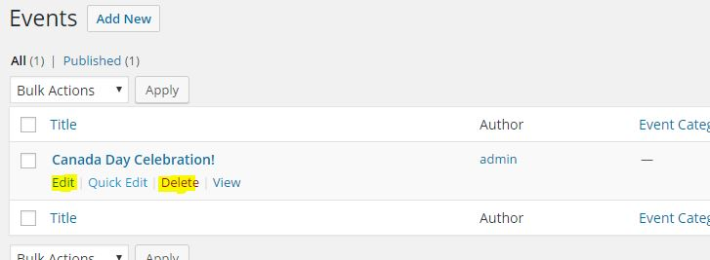

*Figure 1.10:* additional features for each event.

3- To update and make changes to an event, follow the same steps as directed in #2 above. However, select “edit” instead. Once directed to the event panel, update the fields and select complete to save the changes made.

1. **Add a video to page**

For the purpose of maintainability, we have opted to use embedding youtube videos as our method of adding videos to a page. In order to embed a video from YouTube, the video must first be available on youtube.

To upload a video to youtube is simple, in fact, follow the steps in this youtube video tutorial to upload a video! <https://www.youtube.com/watch?v=aHocQeo9ibY&feature=youtu.be>

1- Next, you’ll want to log in to WordPress, and find the page you want to add a video to by clicking on “Pages” in the dashboard as shown in figure 2.1.

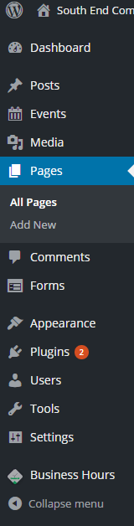

Figure 2.1:

2- When you’ve clicked pages you should be presented with a list of existing pages as shown in figure 2.2. Find the one you’d like to add a video to and hover your mouse over the page. You will get a list of options like the one in the figure below:  
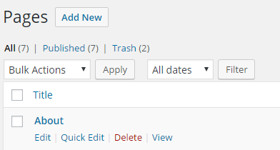  
  
figure 2.2:

3- Click “Edit” to edit the page. You should now see the page you’ve selected in the page editor as shown below figure 2.3:  
  
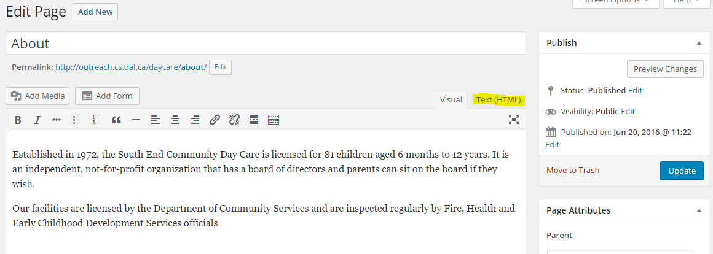  
figure 2.3:

4- Click on the tab “Text(HTML). You should now see the same content as shown in figure 2.4, but it might look a little less polished, that is OK.

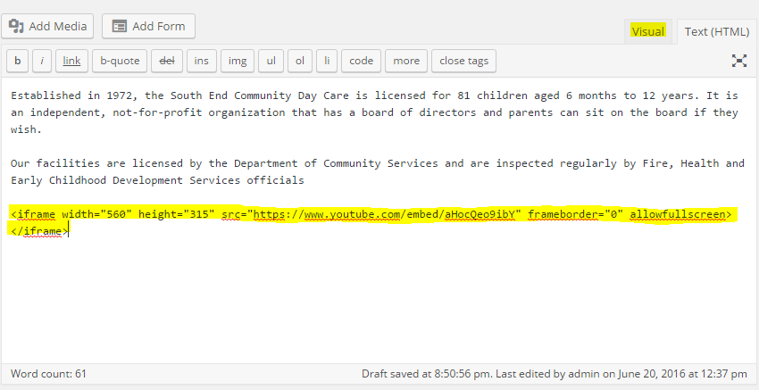

Figure 2.4:

5- In another window or browser tab, find the youtube video you’d like to add to your website as shown in figure 2.5.

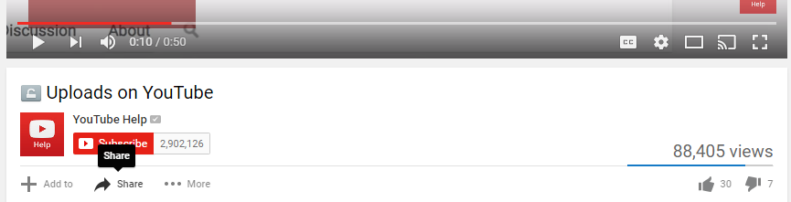

Figure 2.5:

6- Scroll to the bottom of the video and click “Share”. You should now see this menu similar to figure 2.6.

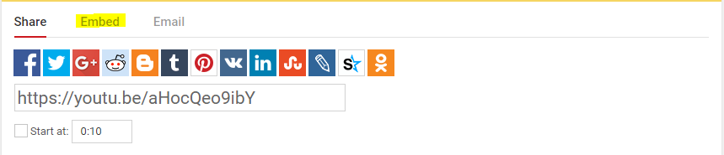

Figure 2.6:

7- Click on “Embed” and copy the highlighted section below in figure 2.7.

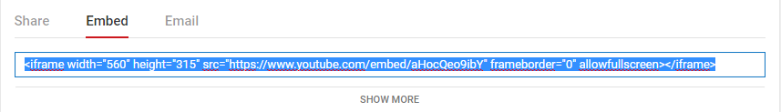

Figure 2.7:

8- Head back to your WordPress page and paste the contents where you’d like to see them in the page. An example is below figure 2.8:

Click the “Visual” tab in the editor to see a preview of the video in the page.

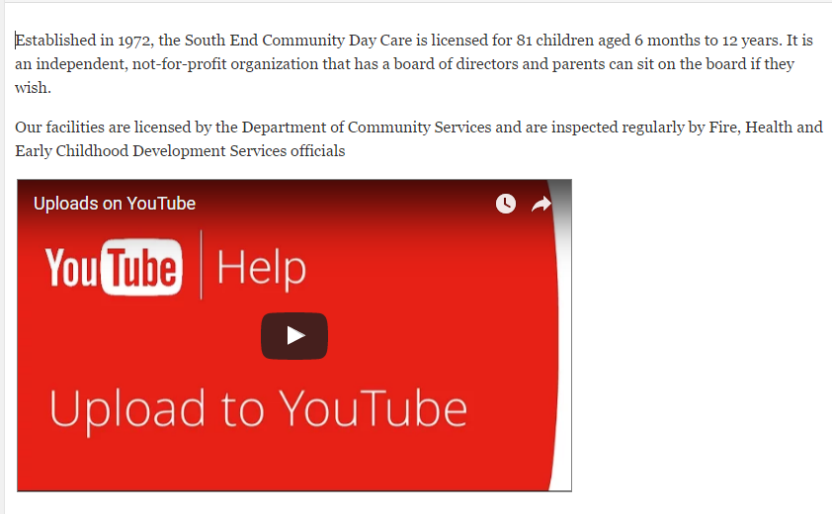

Figure 2.8: Setting position of video by embedding

If you are satisfied with the page, click “Save” to publish the content!

**Trouble Shooting technique**